Networking career development program.

**Assignment: 1**

**Module -1 Understanding of Hardware and its Components**

**Section 1: Multiple choice**

1. **Which of the following is NOT a component of the CPU?**

* RAM

1. **What is the function of RAM in a computer?**

* Random Access Memory (RAM) serves as a computer's short-term memory, holding data needed for immediate access during operation. It functions as where active programs, files, and data required by the processor are temporarily stored.
* **Key functions of RAM include:**

1. **Temporary storage:** It holds data temporarily, such as programs in use, active files, and information the processor needs to process.
2. **Fast access:** Designed for rapid read and write speeds, allowing the processor to quickly retrieve and store data, essential for efficient computer performance.
3. **Volatility:** RAM is volatile, meaning stored data is erased when power is turned off. Therefore, it's crucial to save work to a more permanent storage device like a hard drive
4. **Which of the following is a primary storage device?**

* 1 and 2 both

1. **What is the purpose of a GPU?**

* Imagine a GPU as a super-powered brain for your computer, specifically designed for tasks that involve visuals.

GPUs are primarily designed to handle the complex calculations needed for rendering images and graphics on screens. This includes tasks such as:

3D Rendering: Creating and displaying realistic 3D objects and environments in games and other applications.

Video Processing: Enhancing video quality, adding effects, and speeding up video editing

Image Processing: Applying filters, enhancing images, and performing other image manipulation tasks.

GPUs are well-suited for tasks that can be broken down into smaller, independent operations. They can perform many of these calculations simultaneously, a process known as parallel processing.

**Section 2: True or False**

1. **True or False: The motherboard is the main circuit board of a computer where other components are attached.**

* True

1. **True or False: A UPS (Uninterruptible Power Supply) is a hardware device that provides emergency power to a load when the input power source fails.**

* True

1. **True or False: An expansion card is a circuit board that enhances the functionality of a component.**

* True

**Section 3: Short Answer**

1. **Explain the difference between HDD and SSD.**

**HDD (Hard Disk Drive):**

**How it works:** Uses spinning platters and a moving read/write head to access data.

**Speed:** Slower read/write speeds compared to SSDs.

**Durability:** More susceptible to physical shock due to moving parts.

**Noise:** Can generate noise due to spinning platters.

**Cost:** Generally, more affordable per gigabyte of storage.

**SSD (Solid State Drive):**

**How it works:** Stores data on flash memory chips with no moving parts.

**Speed:** Significantly faster read/write speeds.

**Durability:** More resistant to physical shock.

**Noise:** Silent operation.

**Cost:** More expensive per gigabyte of storage, but prices are decreasing.

1. **Describe the function of BIOS in a computer system.**

**Function of BIOS**

BIOS (Basic Input/Output System):

1. **Initialization:** Performs power-on self-tests (POST) to check hardware components.
2. **Hardware Configuration**: Manages basic hardware settings (e.g., boot order, clock settings).
3. **Operating System Loading**: Loads the operating system from storage into memory.
4. **Communication**: Acts as an interface between the operating system and hardware.
5. **List and briefly explain three input devices commonly used with computers.**

**Three Common Input Devices**

1. **Keyboard:** Used for entering text, numbers, and commands**.**
2. **Mouse:** Used for navigation, selection, and other actions on the screen.
3. **Microphone:** Used for audio input, such as voice commands or recording.

**SECTION 4 Practical Application**

1. **Identify and label the following components on a diagram of a motherboard:**

**● CPU**

**● RAM slots**

**● SATA connectors**

**● PCI-E slot**

* motherboard with CPU, RAM slots, SATA connectors, and PCIE slot labelled.

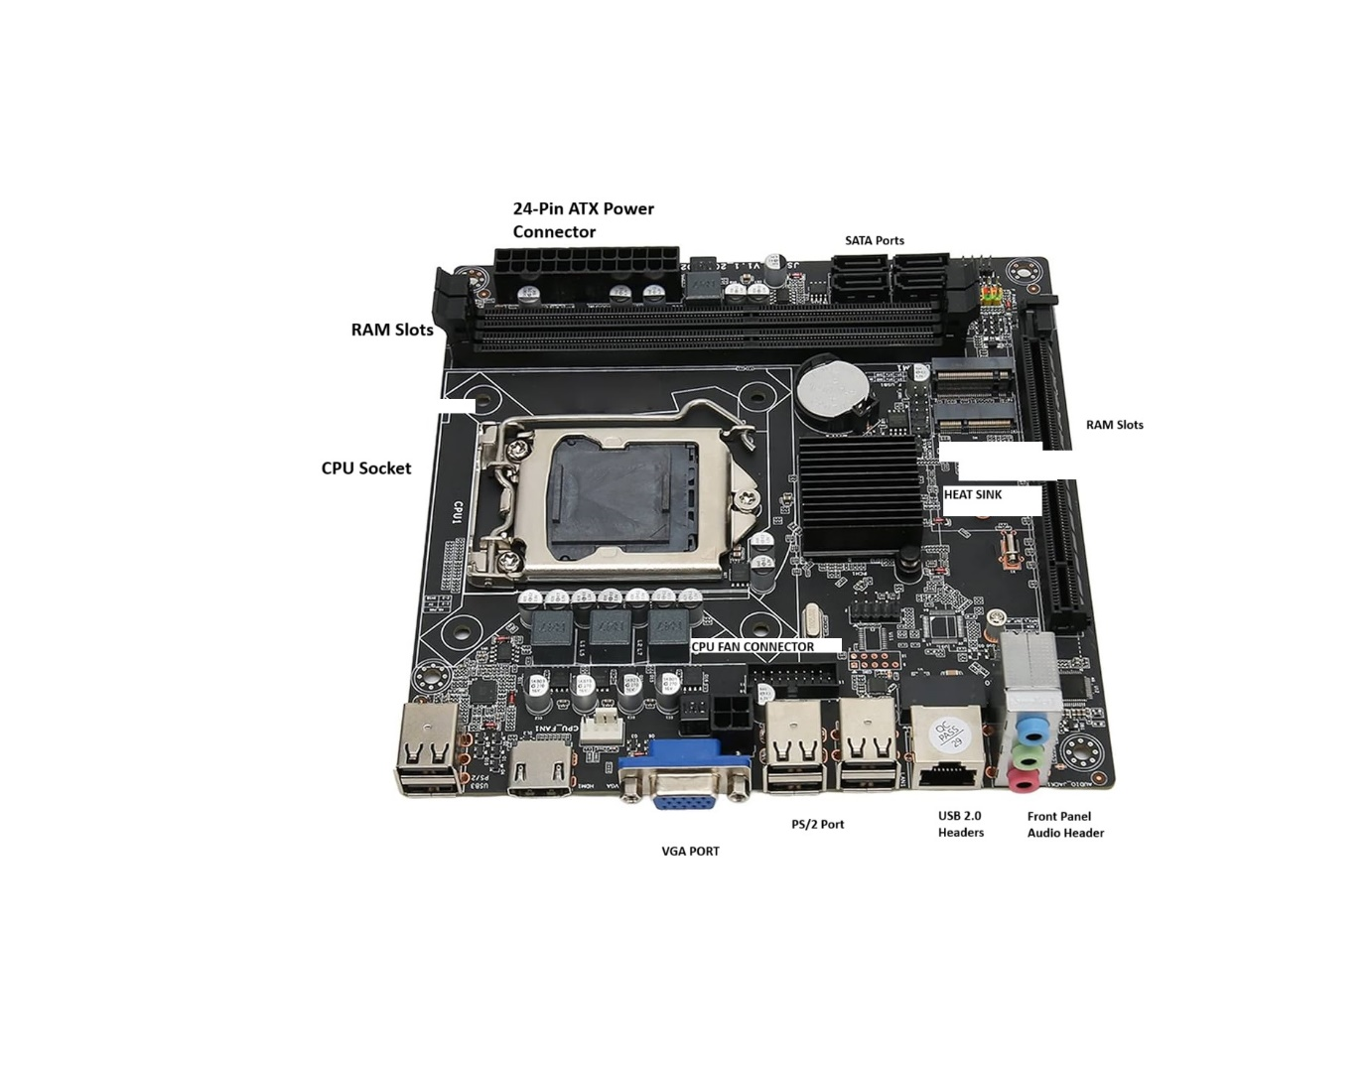

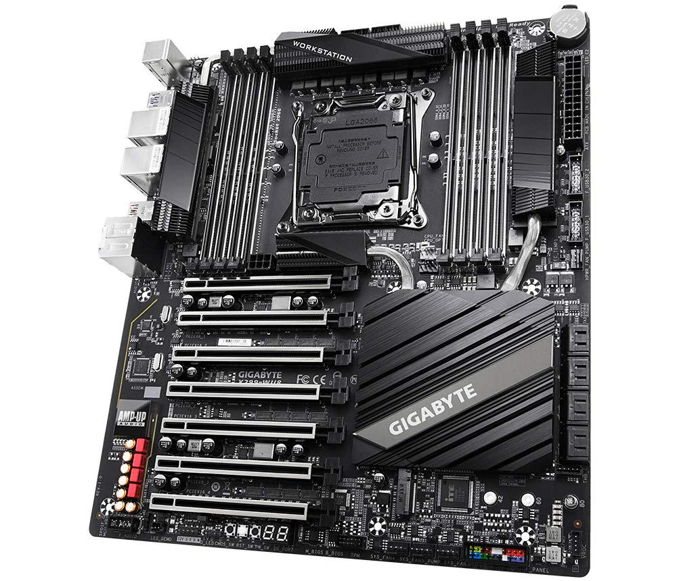

Let's break down each component:

**-> CPU (Central Processing Unit):**

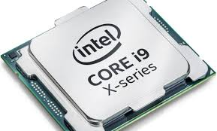

This is the brain of the computer, responsible for executing instructions and performing calculations. It's typically a large, integrated circuit located in a socket on the motherboard.

**-> RAM Slots:**

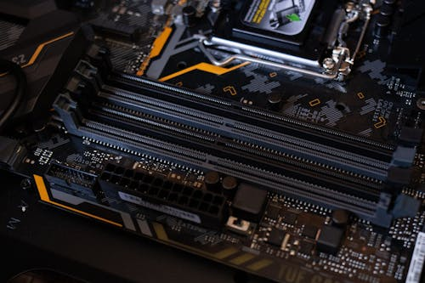

These slots hold Random Access Memory (RAM) modules, which act as short-term storage for the CPU. RAM allows the computer to quickly access frequently used data.

**-> SATA Connectors:**

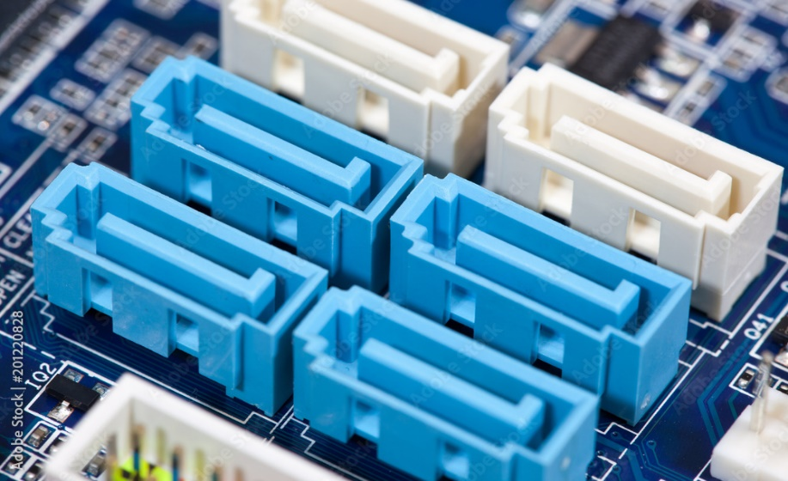

These connectors are used to connect Serial ATA hard drives and solid-state drives (SSDs) to the motherboard. SATA is a high-speed interface for data transfer.

**-> PCI-E Slot:**

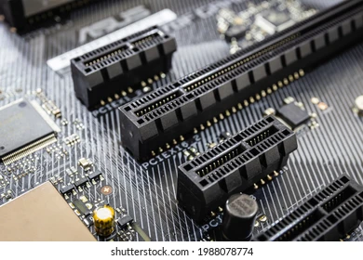

This slot is used to connect expansion cards, such as graphics cards, sound cards, and network cards, to the motherboard. PCI-E (Peripheral Component Interconnect Express) is a high-speed serial expansion bus standard.

1. **Demonstrate how to install a RAM module into a computer.**

* **Installing a RAM Module**: A Step-by-Step Guide

1. **Preparation and Safety**

**Power Down:** Turn off your computer completely and unplug the power cable.

**Ground Yourself:** Touch a metal part of the computer case to discharge any static electricity.

**Open the Case:** Carefully open your computer's case using the appropriate tools.

1. **Locate the RAM Slots**

Identify the RAM slots on your motherboard. They are usually long, narrow slots with clips on the sides.

1. **Remove Existing RAM (if applicable)**

If you're replacing existing RAM, gently press down on the clips on either side of the module. The module should pop up slightly. Carefully pull the module straight out of the slot.

1. **Insert the New RAM**

Align the notch on the RAM module with the corresponding key on the slot. Gently but firmly insert the module into the slot at an angle.

Push the module down until it clicks into place. The clips on the sides should lock it in.

1. **Close the Case and Power On**

Close your computer's case securely.

Plug the power cable back in.

Turn on your computer.

**Important Tips:**

**Compatibility**: Ensure the new RAM is compatible with your motherboard and system requirements.

**Force**: Don't force the RAM module into the slot. If it doesn't fit easily, double-check the alignment.

**SECTION 5 Essay**

1. **Discuss the importance of proper cooling mechanisms in a computer system. Include examples of cooling methods and their effectiveness.**

Importance of Proper Cooling Mechanisms in a Computer System

Overheating: Computer components, especially the CPU and GPU, generate significant heat during operation. Overheating can lead to:

**System Instability**: Crashes, freezes, and unexpected shutdowns.

Performance Degradation: Reduced processing speeds as the system throttles performance to prevent overheating.

**Hardware Damage:** Permanent damage to components like the CPU, GPU, and motherboard.

**Data Loss**: In extreme cases, overheating can corrupt data stored on the hard drive.

**Cooling Methods:**

1. **Passive Cooling:**
2. **Heat Sinks:** Large metal structures that absorb heat from the component and dissipate it into the surrounding air.
3. **Heat Pipes:** Utilize the principle of capillary action to efficiently transfer heat from the heat source to a heat sink.
4. **Active Cooling:**
5. **Fans:** Move air across heat sinks to accelerate heat dissipation.
6. **Liquid Cooling**: Uses a circulating fluid (water or coolant) to absorb heat from the components and transfer it to a radiator.
7. **AIO (All-in-One) Liquid Coolers:** Self-contained units with a pump, radiator, and fans for easy installation.

**Effectiveness:**

**Factors:** Ambient temperature, component workload, and the quality of the cooling solution all influence effectiveness.

**Importance:** Proper cooling is crucial for maintaining system stability, maximizing performance, and ensuring the longevity of your computer hardware.

1. **Explain the concept of bus width and its significance in computer architecture.**

**Bus Width and its Significance**

**Bus**: A pathway within a computer that transmits data between components.

**Bus Width:** The number of bits that can be transferred simultaneously over the bus. A wider bus allows for faster data transfer.

Significance:

**Data Transfer Speed:** A wider bus can transfer more data per clock cycle, significantly impacting overall system performance.

**Bottlenecks**: Narrower buses can become bottlenecks, limiting the speed of data transfer between components and hindering overall system performance.

**Examples:**

**Data Bus:** Transfers data between the CPU and memory.

**Address Bus:** Carries memory addresses to the CPU.

**PCI Express (PCIe**): A high-speed serial expansion bus with varying widths (x1, x4, x8, x16, etc.) that determines its bandwidth.